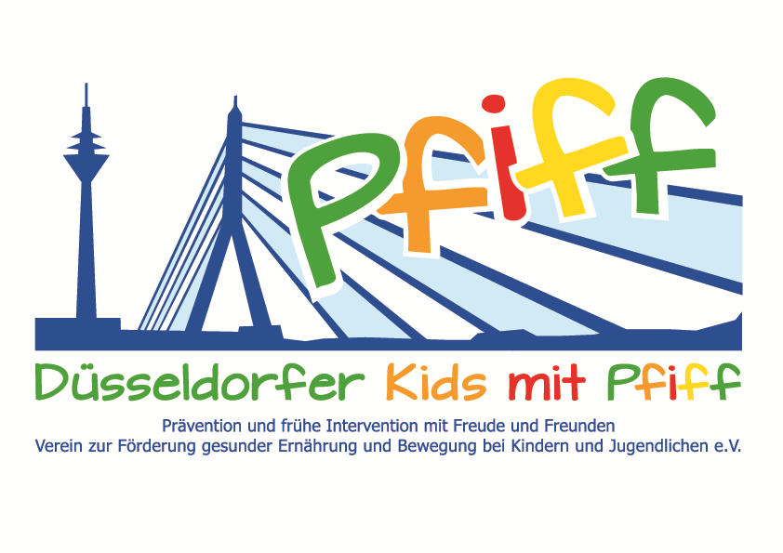
Düsseldorf, December 7, 2017

Press Release

Sport Lessons with Top Athletes
The primary school children participating in the initiative "SMS. Be smart. Join in. Be fit." of the DZD partner German Diabetes Center completed a training session with the SMS sponsors.
(Düsseldorf, 7.12.2017) A balanced diet and regular exercise have a strong influence on health and performance. However, current surveys show that only 15 percent of children and young people exercise for at least one hour per day and that the number of overweight children currently doubles during their school years. In order to counteract this development and to enable the participating students to find fun in exercise and a healthy lifestyle, the SMS initiative receives support from active and former top athletes. In the past few weeks, the German team champion in cross-country running Dr. Dorothee Mechau, the world champion in rowing Leonie Pieper and the European football champion and UEFA-CUP winner Thomas Helmer visited the classes of the GGS Max-Halbe-Straße, the GGS Stoffeler Straße and the Matthias-Claudius-Schule. During a joint sports lesson, the children were able to get to know the athletes, learn a lot about the respective sport and try out specific exercise units for themselves.
Thomas Helmer emphasized the importance of the SMS initiative: "When children at a young age are made aware of the significance of a balanced diet and regular exercise, this has a life-long effect and also has a positive effect on their own body feeling and well-being.” “For primary school pupils, it is always something very special when a prominent athlete comes to them in school. Our sponsors are therefore excellently suited to inspire the children for a healthy lifestyle," said project leader Professor Karsten Müssig, expressing his pleasure at the strong support given by the many SMS sponsors.
The initiative “SMS. Be smart. Join in. Be fit." led by Professor Karsten Müssig at Düsseldorf primary schools, seeks to counteract overweight and other lifestyle-related diseases in childhood and adolescence. The SMS initiative is sponsored by the Düsseldorf association Kids mit PFIFF and scientifically supported by the German Diabetes Center (DDZ). The participating children complete the “aid” nutrition pilot license program in cooperation with the Education Center for Dietary Assistants of the Kaiserswerther Diakonie and take part in the exercise program for primary schools “Fitness for Kids” developed by sports scientist Professor Kerstin Ketelhut. In addition, the pupils are provided guidance in stress regulation through a “sensory classroom” of a motor skills training course of the Präha Weber School. They are also taught relaxation exercises in cooperation with the initiative “Physical Activity during School Recess” of the Dietrich Grönemeyer Foundation and the Deichmann company. The two health insurance companies IKK classic and KKH, the organization diabetesDE - German Diabetes Aid, the Sports Department of Düsseldorf and other renowned partners and prominent people support the project and provide the participating school children with additional attractive venues for learning outside of school. The patron of the initiative is Thomas Geisel, mayor of the state capital Düsseldorf.

In 2015 the SMS initiative was awarded the supporter logo of IN FORM – Germany’s initiative for a healthy diet and more exercise, and in 2016 was awarded the GUT DRAUF label of the German Center for Health Education (BZgA).

More information at: www.sms-mach-mit.de

