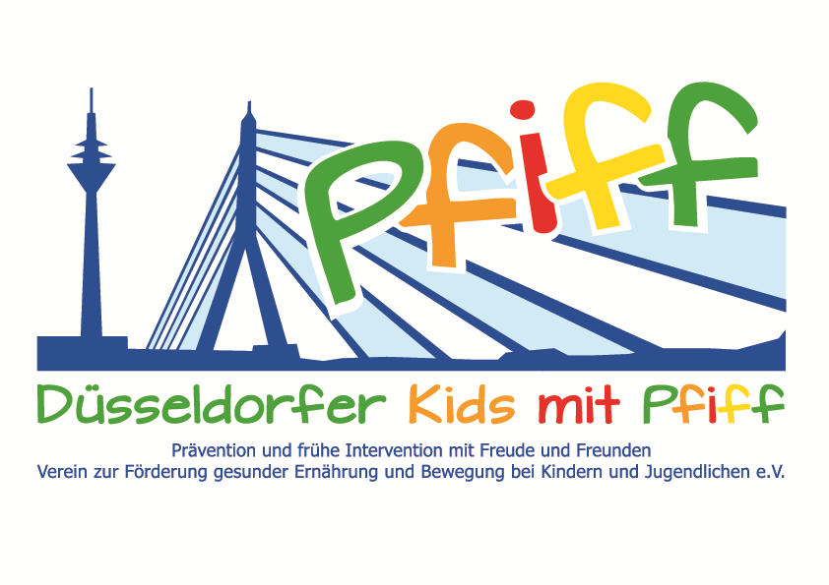
Düsseldorf, January 2, 2018

Press Release
Donation to Promote Diabetes Prevention
The Glomm Bakery and Pastry Shop and Fortuna Düsseldorf Clubhaus Bar95 support the SMS initiative.
Good things can hardly be done better: To begin with, the initiative "SMS. Be smart. Join in. Be fit." of the German Diabetes Center was presented a check; then, in connection with the donation, the participating primary school pupils of the Matthias Claudius School were given a giant Weckmann (a bun similar to a gingerbread man, but made out of bread dough). Klaus Glomm, owner of the Glomm Bakery and Pastry Shop, and Tim Olepp, owner of the Fortuna Düsseldorf clubhouse Bar95, have been collecting money for the SMS initiative in recent weeks, among other places at a charity football tournament at the Paul Janes Stadium. Now the sum total of 495 euros was presented to SMS project leader Professor Karsten Müssig. The SMS initiative promotes healthy habits in kids and teens and long-term prevention of obesity and lifestyle-related illnesses in childhood. This donation will enable many pupils to participate in the initiative's activities next year and learn how easy it is to eat a balanced diet and how much fun regular exercise is.
For the occasion of the presentation of the donation, Klaus Glomm baked a huge Weckmann and decorated it elaborately with a Fortuna jersey and the logo of the Bar95. In order to enable the participating children of the SMS initiative to participate in this gift, Klaus Glomm and Professor Karsten Müssig jointly presented the Weckmann to the pupils of the Matthias Claudius School, who enthusiastically accepted it and enjoyed sharing it with each other.
“To see how the children enjoyed the Weckmann and the enthusiasm with which they ate it encourages me to continue to dedicate myself to this good cause. Such actions show how easy it is to do good and make children happy,” said bakery owner Klaus Glomm, expressing his pleasure about the successful campaign. Tim Olepp added: “As a former training leader of the SMS initiative, I am particularly pleased to continue to support the project after my active time and to make a contribution to give children the joy of exercise and a healthy diet at an early age. This is the only way to ensure a healthy life in the long term.” We are very happy about the generous donation from Mr. Glomm and Mr. Olepp. SMS project leader Prof. Karsten Müssig stressed the importance of the initiative: ”The money will help us to continue to offer the SMS project to primary school classes and to promote the prevention of obesity and lifestyle-related diseases on a large scale in the Düsseldorf area.”
The initiative “SMS. Be smart. Join in. Be fit." led by Professor Karsten Müssig at Düsseldorf primary schools, seeks to counteract overweight and other lifestyle-related diseases in childhood and adolescence. The SMS initiative is sponsored by the Düsseldorf association Kids mit PFIFF and scientifically supported by the German Diabetes Center (DDZ). The participating children complete the “aid” nutrition pilot license program in cooperation with the Education Center for Dietary Assistants of the Kaiserswerther Diakonie and take part in the exercise program for primary schools “Fitness for Kids” developed by sports scientist Professor Kerstin Ketelhut. In addition, the pupils are provided guidance in stress regulation through a “sensory classroom” of a motor skills training course of the Präha Weber School. They are also taught relaxation exercises in cooperation with the initiative “Physical Activity during School Recess” of the Dietrich Grönemeyer Foundation and the Deichmann company. The two health insurance companies IKK classic and KKH, the organization diabetesDE - German Diabetes Aid, the Sports Department of Düsseldorf and other renowned partners and prominent people support the project and provide the participating school children with additional attractive venues for learning outside of school. The patron of the initiative is Thomas Geisel, mayor of the state capital Düsseldorf. In 2015 the SMS initiative was awarded the supporter logo of IN FORM – Germany’s initiative for a healthy diet and more exercise, and in 2016 was awarded the GUT DRAUF label of the German Center for Health Education (BZgA).
More information at: www.sms-mach-mit.de

