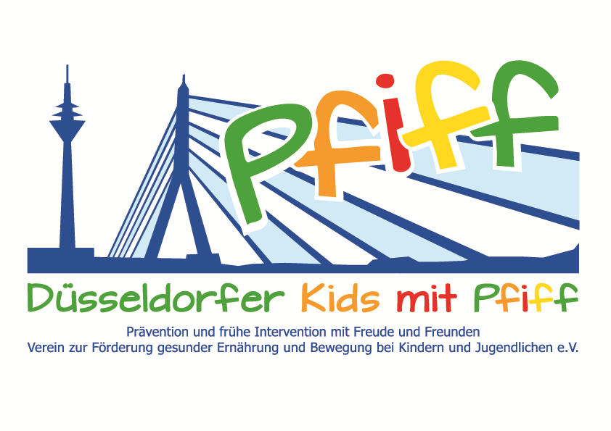
Düsseldorf, February 27, 2018

Press Release

Olympic Champion Supports Diabetes Prevention

Udo Hempel highlights the fascination of sports in a talk to primary school children participating in the SMS initiative.
(Düsseldorf, February 26, 2018) At present, the number of overweight children doubles during their school years. The adverse effect of being overweight is not limited to childhood, but can also have a significant impact on the child’s further development up to and including adulthood. In view of this fact, the SMS initiative “Be smart. Join in. Be fit " is advocating a balanced lifestyle during the growing up years and promoting long-term prevention of obesity and lifestyle-related diseases in childhood. The visits of the SMS sponsors to the schools and the participation of the classes in extracurricular learning venues are an important part of the initiative. In this context, the children gather authentic experiences in various sports, discover the basics and diversity of a balanced diet and learn forms of stress regulation. On February 27, 2018, Udo Hempel, world champion and Olympic champion in cycling, will visit the pupils of the municipal primary school on Flurstraße in Flingern. The former top athlete, who is still very active in sports today, grew up in the Düsseldorf district of Flingern and went to school there. As part of a motivational talk on the topic “Sports Training Pays Off“, he will describe to the children on the basis of his own development and his sporting career what is possible through regular exercise and how much fun and joy go along with it. To illustrate this, he will show the children a video of the 1972 Olympic finals, in which Udo Hempel and his team-mates won the gold medal in team pursuit.
“Young people need visions, goals and above all role models. Whoever is committed to a cause with passion and desire and has a certain discipline, is on the right track. As a former competitive athlete, I support the goals of the SMS initiative and am glad to convey the relevance of a healthy lifestyle to primary school students," said SMS sponsor Udo Hempel. “The sponsors of the SMS initiative not only stand for the cause with their name, but also enrich the lessons of the participating schools through their visits. In this way, they show the children what can be possible with regular exercise and a balanced diet," said project manager Professor Karsten Müssig, lauding the support of the SMS sponsors.
The initiative led by Professor Müssig, “SMS. Be smart. Join in. Be fit." seeks to counteract and overweight and other lifestyle-related diseases in childhood and adolescence. The SMS initiative is sponsored by the association Düsseldorf Kids' with PFIFF and is scientifically supported by the German Diabetes Center (DDZ). The participating children complete the “aid” nutrition pilot license program in cooperation with the Education Center for Dietary Assistants of the Kaiserswerther Diakonie and take part in the exercise program for primary schools “Fitness for Kids” developed by sports scientist Professor Kerstin Ketelhut. In addition, the pupils experience the perception of their own body in the sensory classroom of the Präha Weber School in a motor skills training course. They are also taught relaxation exercises in cooperation with the initiative “Physical Activity during School Recess” of the Dietrich Grönemeyer Foundation and the Deichmann company. The two health insurance companies IKK classic and KKH, the organization diabetesDE - German Diabetes Aid, the Sports Department of Düsseldorf and other renowned partners and prominent people support the project and provide the participating school children with additional attractive venues for learning outside of school. The patron of the initiative is Thomas Geisel, mayor of the state capital Düsseldorf.
In 2015 the SMS initiative was awarded the supporter logo of IN FORM – Germany’s initiative for a healthy diet and more exercise, and in 2016 was awarded the GUT DRAUF label of the German Center for Health Education (BZgA).

Date and Venue:
Udo Hempel, February 27, 2018, 12:00 – 12:45 pm
GGS Flurstraße, Flurstraße 59, 40235 Düsseldorf

For more information on the initiative, see: www.sms-mach-mit.de

