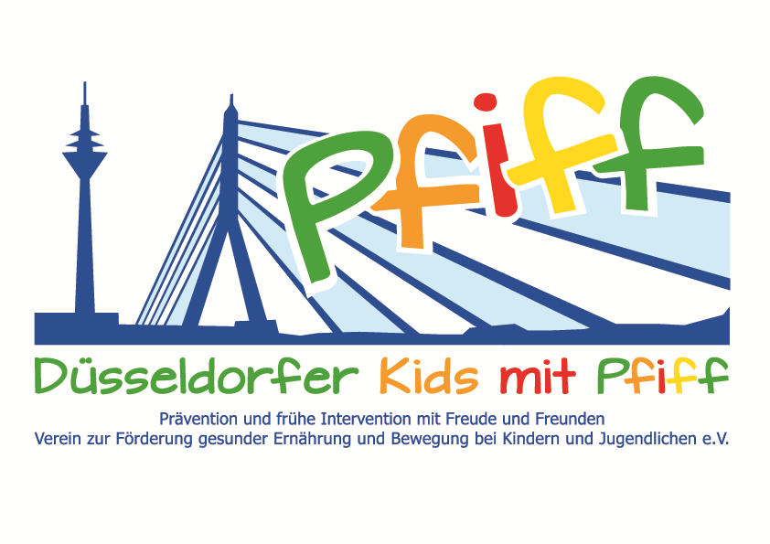
Düsseldorf, March 1, 2018

Press Release

Cooking for a Balanced Lifestyle
KochDichTurkish offers the participating pupils of the SMS initiative a cooking course for kids.
(Düsseldorf, February 27, 2018 Besides regular exercise, a balanced diet is of great importance in the treatment and prevention of lifestyle-related diseases such as obesity and diabetes. In the cooking class for kids, KochDichTürkisch (Learn to Cook Turkish Food), primary school pupils participating in the initiative “SMS. Be smart. Join in. Be fit.” learn how easy and fun it is to prepare and eat healthy foods. Together with the cookbook authors and founders of KochDichTürkisch, Orkide and Orhan Tançgil, the students of the Matthias Claudius School prepare various dishes and learn more about the diversity and traditions of Turkish cuisine. The menu has been designed so that it is also easy for the children to cook at home. Special emphasis is placed on the use of fresh and seasonal ingredients. On February 27 and 28, 2018, the menu includes minced meat balls (köfte), small rolls of dough with various fillings (sigara börek), Bulgur pilaf with vegetables and tomato-cucumber salad with pomegranate syrup (kaşık salatası) and the traditional ayran yoghurt drink. The children can take the recipes home with them after the cooking course. In Turkish culture, eating and preparing food together is part of everyday life. In Germany, however, less and less often are meals prepared, cooked and eaten together with the whole family. "Cooking and eating together strengthens cohesion and is also important in the long term to introduce children to a balanced diet and healthy lifestyle. In addition, cooking boosts motor skills and provides a great opportunity to get to know different cultures," said Orkide and Orhan Tançgil, stressing the importance of involving children in meal preparation. “Doing one’s own cooking is not only fun and tasty, but also healthy. We would like to give the children the opportunity to have this experience through this cooking class," said SMS project leader Professor Karsten Müssig.
Dates:
February 27, 2018 and February 28, 2018, 09:30 AM – 1:00 PM
KochDichTürkisch, Birkenstraße 86, 40233 Düsseldorf

The initiative led by Professor Müssig, “SMS. Be smart. Join in. Be fit." in Düsseldorf primary schools seeks to counteract overweight and other lifestyle-related diseases in childhood and adolescence. The SMS initiative is sponsored by the association Düsseldorfer Kids mit PFIFF and is scientifically supported by the German Diabetes Center (DDZ). The participating children complete the “aid” nutrition pilot license program in cooperation with the Education Center for Dietary Assistants of the Kaiserswerther Diakonie and take part in the exercise program for primary schools “Fitness for Kids” developed by sports scientist Professor Kerstin Ketelhut. In addition, the pupils are taught how to deal with stress in the sensory classroom of the Präha Weber School in a motor skills training course. They are also taught relaxation exercises in cooperation with the initiative “Physical Activity during School Recess” of the Dietrich Grönemeyer Foundation and the Deichmann company .The two health insurance companies IKK classic and KKH, the organization diabetesDE - German Diabetes Aid, the Sports Department of Düsseldorf and other renowned partners and prominent people support the project and provide the participating school children with additional attractive venues for learning outside of school. The patron of the initiative is Thomas Geisel, mayor of the state capital Düsseldorf.
In 2015 the SMS initiative was awarded the supporter logo of IN FORM – Germany’s initiative for a healthy diet and more exercise, and in 2016 was awarded the GUT DRAUF label of the German Center for Health Education (BZgA).
For more information on the initiative, see: www.sms-mach-mit.de

