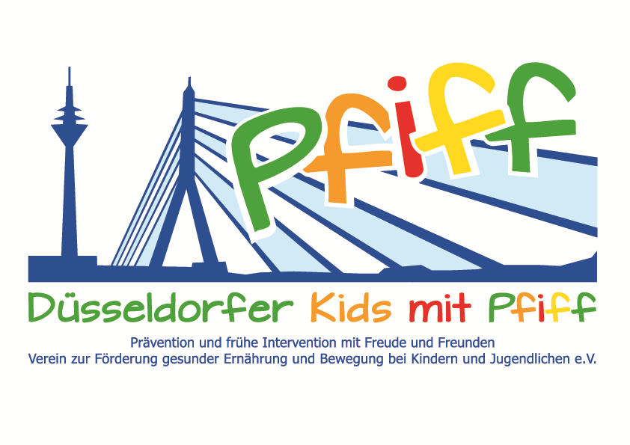
Düsseldorf, March 15, 2018

Press Release

Diabetes Prevention through Fun Exercise Activities
The Düsseldorf Sports Club 1899 invites the primary school children participating in the SMS initiative to a taster hockey training session.
(Düsseldorf, March 9, 2018) In addition to a balanced diet, regular exercise is very important for the healthy growth of children. That is why the "SMS. Be smart. Join in. Be fit.“ initiative, conducted together with numerous partners and sponsors, gives the participating primary school pupils an insight into the diversity of the existing sports and exercise offers. By visiting sports clubs and partners in the field of exercise, the children get to know new forms of exercise and have the opportunity to actively discover and try them out with all their senses. These authentic experiences help to arouse the enjoyment of regular physical activity and shape the behavior of elementary students in terms of an active and healthy lifestyle. As partner of the SMS initiative, the Düsseldorf Sports Club 1899 has invited the children of the Paul Klee School Düsseldorf to a hockey taster training. For years the DSC 99 has placed great emphasis on good youth work with qualified coaches. Over 20 youth hockey teams are supervised and accompanied in the DSC 99 by the coaching team led by Gabi Schöwe, certified sports teacher and silver medalist in hockey at the 1984 Olympic Games. Hockey combines the components coordination, speed, agility and versatility and is therefore ideal for team sports. During the taster training, the children learn how to control the ball and pass and receive it with the hockey stick. Through a combination of coordination and skill exercises, the students get a feeling for the ball, which they can then demonstrate in the final goal-shooting training.
“The DSC 99 wants to convey to the children how much fun it is to play hockey and exercise in a team. In this context, the SMS initiative perfectly matches our mission and as SMS sponsor, I am pleased to make a contribution to the prevention of lifestyle-related diseases,” said Gabi Schöwe, SMS sponsor and Olympics silver medalist in hockey, explaining her commitment. “Due to its versatility, hockey is particularly suited to inspire children to lead a healthy lifestyle and to exercise regularly. We are always delighted to see the children’s enthusiasm and how much fun they have in the taster training courses offered by our partners,” said project leader Professor Karsten Müssig, highighting the importance of learning venues outside of school.
The initiative led by Professor Müssig, “SMS. Be smart. Join in. Be fit." in Düsseldorf primary schools seeks to counteract overweight and other lifestyle-related diseases in childhood and adolescence. The SMS initiative is sponsored by the association Düsseldorfer Kids mit PFIFF and is scientifically supported by the German Diabetes Center (DDZ). The participating children complete the “aid” nutrition pilot license program in cooperation with the Education Center for Dietary Assistants of the Kaiserswerther Diakonie and take part in the exercise program for primary schools “Fitness for Kids” developed by sports scientist Professor Kerstin Ketelhut. In addition, the pupils are taught how to deal with stress in a motor skills training course in the sensory classroom of the Präha Weber School. They are also taught relaxation exercises in cooperation with the initiative “Physical Activity during School Recess” of the Dietrich Grönemeyer Foundation and the Deichmann company. The two health insurance companies IKK classic and KKH, the organization diabetesDE - German Diabetes Aid, the Sports Department of Düsseldorf and other renowned partners and prominent people support the project and provide the participating school children with additional attractive venues for learning outside of school. The patron of the initiative is Thomas Geisel, mayor of the state capital Düsseldorf. In 2015 the SMS initiative was awarded the supporter logo of IN FORM – Germany’s initiative for a healthy diet and more exercise, and in 2016 was awarded the GUT DRAUF label of the German Center for Health Education (BZgA).

Date:
Wednesday, March 14, 2018, 8:45 – 10:15 AM
Düsseldorfer Sport-Club 1899, Diepenstraße 99, 40625 Düsseldorf

Further information can be found at: www.sms-mach-mit.de

