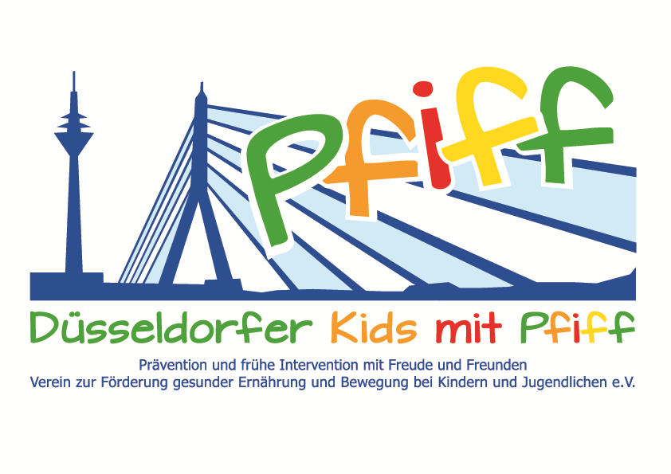
Düsseldorf, March 22, 2018

Press Release

Mastering the School Day with a Well-Balanced Diet

The “aid” nutrition pilot license program is carried out in the participating primary school classes of the SMS initiative.
(Düsseldorf, March 19, 2018) To navigate the challenges of a school day, a balanced diet is essential. The initiative "SMS. Be smart. Join in. Be fit.", in cooperation with the Health Education Center for Dietary Assistants of the Kaiserswerther Diakonie, organizes the annual “aid” nutrition pilot license program in the participating primary schools to teach the children the basics of a balanced diet. The prospective dietary assistants prepare individual and varied lesson plans in advance for the participating classes, in which they teach the children not only the basics of a balanced diet but also the practical handling of food and kitchen appliances. With the help of posters, games and exercise sheets, the third grade pupils learn about the structure and significance of the food pyramid and, based on this knowledge, prepare dishes such as fruit quark, herbal dips and funny bread faces, which the children then eat together. A basic requirement for a healthy lifestyle is to know what a balanced diet is and how easy it is to prepare tasty and healthy food even in a short time. Since the trend in eating habits in recent years has shown that more and more people are eating industrially processed food products instead of home-cooked meals, an important goal of the prospective diet assistants is to give children a sense of the sugar content of preprocessed food products and to show them the variety of foods. Of course, fun comes first. As a special award, the students receive the “aid” nutrition pilot license after completing the lessons.
“In primary school the course is set for a healthy lifestyle. Cooking your food yourself is not only fun and delicious, it is also healthy. We want to impart this concept to the children,“ said Professor Karsten Müssig, project leader of the SMS initiative. “For the prospective dietary assistants of our school it is always a very special experience to carry out the “aid” nutrition pilot license program with the SMS children. “We are pleased to support the objectives of the SMS initiative with our expertise and to convey to the children the benefits of a balanced diet," added Inga Schendzielorz, teacher in the Health Education Center, Dietary Assistant Certification Program of the Kaiserswerther Diakonie.
The initiative led by Professor Müssig, “SMS. Be smart. Join in. Be fit." in Düsseldorf primary schools seeks to counteract overweight and other lifestyle-related diseases in childhood and adolescence. The SMS initiative is sponsored by the association Düsseldorfer Kids mit PFIFF and is scientifically supported by the German Diabetes Center (DDZ). The participating children complete the “aid” nutrition pilot license program in cooperation with the Health Education Center for Dietary Assistants of the Kaiserswerther Diakonie and take part in the exercise program for primary schools “Fitness for Kids” developed by sports scientist Professor Kerstin Ketelhut. In addition, the pupils are taught how to deal with stress in the sensory classroom of the Präha Weber School in a motor skills training course. They are also taught relaxation exercises in cooperation with the initiative “Physical Activity during School Recess” of the Dietrich Grönemeyer Foundation and the Deichmann company .The two health insurance companies IKK classic and KKH, the organization diabetesDE - German Diabetes Aid, the Sports Department of Düsseldorf and other renowned partners and prominent people support the project and provide the participating school children with additional attractive venues for learning outside of school. The patron of the initiative is Thomas Geisel, mayor of the state capital Düsseldorf.
In 2015 the SMS initiative was awarded the supporter logo of IN FORM – Germany’s initiative for a healthy diet and more exercise, and in 2016 was awarded the GUT DRAUF label of the German Center for Health Education (BZgA).

Date and Venue:
Wednesday, March 21, 2018, 8:00 AM – 12:00 Noon
Mosaikschule, Am Massenberger Kamp 45, 40589 Düsseldorf

For more information on the initiative, see:: www.sms-mach-mit.de

