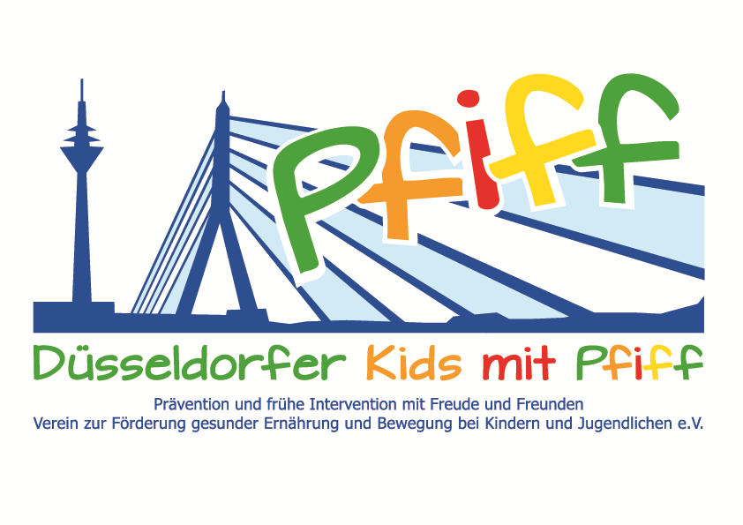
Düsseldorf, May 11, 2018

Press Release

Nutrition Education Up Close

Primary school children participating in the SMS initiative visited the Hercules Bakery.
(Düsseldorf, May 11, 2018) A balanced diet is of great importance in the treatment and prevention of lifestyle-related diseases such as obesity and diabetes. Especially in childhood and adolescence, a well-balanced breakfast is essential to replenish the energy reserves in the morning and to ensure optimal performance during the school day. An integral part of this is whole grain bread. Why whole grain bread is so healthy, what ingredients are contained in it and how it is produced were the focus of a visit by primary school children participating in the initiative "SMS. Be smart. Join in. Be fit" to the Hercules Bakery on Wednesday, May 9, 2018.
During a tour of the bakery, the pupils gained insight into the production of bread and baked products and learned about the differences between the various types of bread. In addition, under the guidance of the owner and master baker Johannes Dackweiler, they had the opportunity to prepare their own pastries and to taste them afterwards.
"In the Hercules Bakery, we attach great importance to freshly preparing and baking each piece of pastry every single day. By visiting the bakery and preparing their own pastries, the children learn what healthy and balanced nutrition means. This is a prerequisite for physical well-being and for being prepared to meet the demands of everyday school life," said master baker Johannes Dackweiler, explaining his commitment to the SMS initiative. "Surveys show that nearly every third child goes to school without having eaten breakfast. To counteract this development, we are trying to get primary school children interested in a balanced diet at an early age. Of course, the focus is on the fun and enjoyment of nutrition, which is wonderfully conveyed through hands-on instruction under expert guidance," said SMS project leader Professor Karsten Müssig, emphasizing the importance of practical nutrition education.

Bildunterschrift: SMS_Hercules Baeckerei.jpg: Children and teachers of the Mosaikschule with SMS project leader Prof. Dr. Karsten Müssig and master baker Johannes Dackweiler (Photo: SMS).
The initiative led by Professor Müssig, “SMS. Be smart. Join in. Be fit." in Düsseldorf primary schools seeks to counteract overweight and other lifestyle-related diseases in childhood and adolescence. The SMS initiative is sponsored by the association Düsseldorfer Kids mit PFIFF and is scientifically supported by the German Diabetes Center (DDZ). The participating children complete the “aid” nutrition pilot license program in cooperation with the Health Education Center for Dietary Assistants of the Kaiserswerther Diakonie and take part in the exercise program for primary schools “Fitness for Kids” developed by sports scientist Professor Kerstin Ketelhut. In addition, the pupils are taught how to deal with stress in the sensory classroom of the Präha Weber School in a motor skills training course. They are also taught relaxation exercises in cooperation with the initiative “Physical Activity during School Recess” of the Dietrich Grönemeyer Foundation and the Deichmann company .The two health insurance companies IKK classic and KKH, the organization diabetesDE - German Diabetes Aid, the Sports Department of Düsseldorf and other renowned partners and prominent people support the project and provide the participating school children with additional attractive venues for learning outside of school. The patron of the initiative is Thomas Geisel, mayor of the state capital Düsseldorf.
In 2015 the SMS initiative was awarded the supporter logo of IN FORM – Germany’s initiative for a healthy diet and more exercise, and in 2016 was awarded the GUT DRAUF label of the German Center for Health Education (BZgA).

For more information on the initiative, see:: www.sms-mach-mit.de

