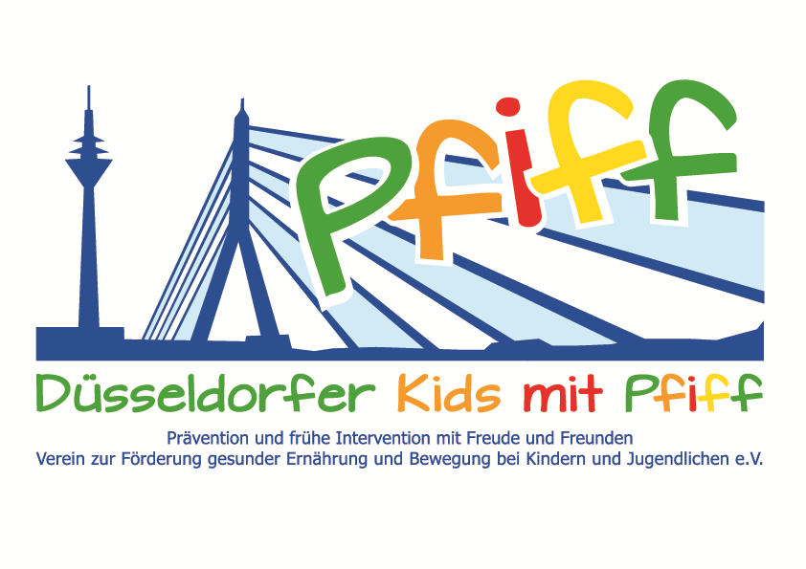
Düsseldorf, May 17, 2018

Press Release

Support for Diabetes Prevention
Stadtsparkasse Düsseldorf Supports the Social Commitment of the SMS Initiative.
(Düsseldorf, May 16, 2018) On Monday, May 14, 2018, the festive presentation of the donation of the PS special-purpose revenue of the Sparkasse lottery “PS Save and Win“ took place in the Kaiserswerth private customer center. Every year, Sparkasse Düsseldorf supports charitable purposes such as support associations of kindergartens and schools, sports clubs or senior citizens' institutions with funds from the PS special-purpose revenue. This year, the initiative "SMS. Be smart. Join in. Be fit" received a donation. The initiative, which is supported by the association Düsseldorf Kids with PFIFF and scientifically accompanied by the German Diabetes Center, was awarded 2300 euros. The donation check was presented to the SMS project coordinator Guido Schenuit by Dirk Günthör, director of the Regional Market North of the Stadtsparkasse Düsseldorf. Besides the other donation recipients, the mayor of the district, Stefan Golißa, also took part in the event.
The SMS initiative is committed to healthy child development and long-term prevention of overweight and lifestyle-related illnesses in childhood. The aim of the initiative is to show primary school children how easy it is to follow a balanced diet and how much fun regular exercise is. The donations from the savings bank lottery "PS Save and Win " are earmarked for the purchase of materials and the organization of events as part of the SMS initiative.
"We very much appreciate the generous donation of the Stadtsparkasse Düsseldorf. The objective of the SMS initiative is to inspire children and raise awareness at an early stage for the importance of a balanced diet and regular exercise, thus paving the way for a healthy lifestyle. The money will help us to further advance the SMS project and to offer the children attractive events, " said SMS project leader Professor Karsten Müssig, emphasizing the importance of donations for the SMS initiative.
Bildunterschrift (SMS_Sparkassenlotterie.jpg): SMS Project Coordinator Guido Schenuit (right) with Dirk Günthör, director of the Regional Market North of Stadtsparkasse Düsseldorf (Photo: SMS).

The initiative led by Professor Müssig, “SMS. Be smart. Join in. Be fit." in Düsseldorf primary schools seeks to counteract overweight and other lifestyle-related diseases in childhood and adolescence. The SMS initiative is sponsored by the association Düsseldorfer Kids mit PFIFF and is scientifically supported by the German Diabetes Center (DDZ). The participating children complete the “aid” nutrition pilot license program in cooperation with the Health Education Center for Dietary Assistants of the Kaiserswerther Diakonie and take part in the exercise program for primary schools “Fitness for Kids” developed by sports scientist Professor Kerstin Ketelhut. In addition, the pupils are taught how to deal with stress in the sensory classroom of the Präha Weber School in a motor skills training course. They are also taught relaxation exercises in cooperation with the initiative “Physical Activity during School Recess” of the Dietrich Grönemeyer Foundation and the Deichmann company .The two health insurance companies IKK classic and KKH, the organization diabetesDE - German Diabetes Aid, the Sports Department of Düsseldorf and other renowned partners and prominent people support the project and provide the participating school children with additional attractive venues for learning outside of school. The patron of the initiative is Thomas Geisel, mayor of the state capital Düsseldorf.
In 2015 the SMS initiative was awarded the supporter logo of IN FORM – Germany’s initiative for a healthy diet and more exercise, and in 2016 was awarded the GUT DRAUF label of the German Center for Health Education (BZgA).

For more information on the initiative, see:: www.sms-mach-mit.de

