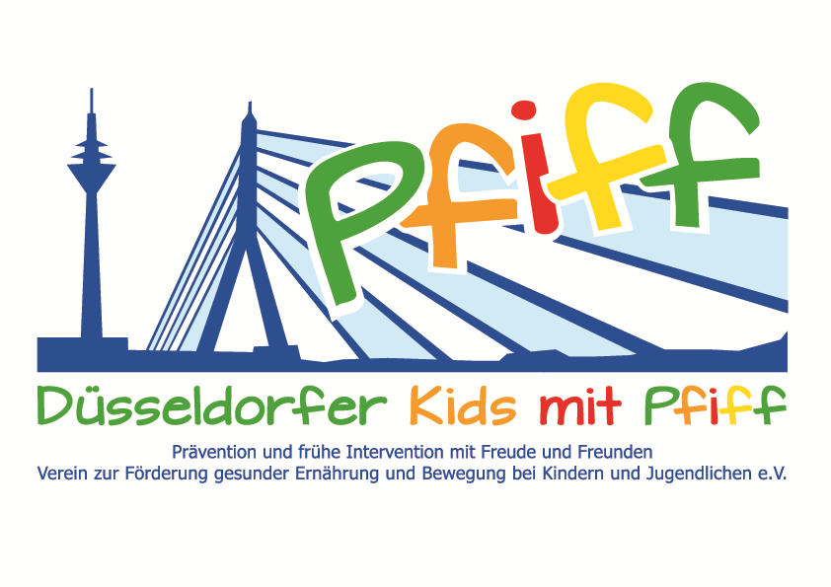
Düsseldorf, May 18, 2018

Press Release

Motivating Kids to Discover the Fun of Exercise
Together with the Football Factory, the SMS initiative organized a one-day football camp for the participating primary school children.

(Düsseldorf, May 18, 2018) For Düsseldorf, the year 2018 is all about football: in addition to the World Cup starting in a few weeks, Fortuna Düsseldorf was able to perfect its promotion to the first German football league this season. But it's even more fun when you get active and score goals yourself. This was the motivational concept behind the initiative “SMS. Be smart. Join in. Be fit.” for the participating primary school children of the St. Rochus School on May 17, 2018. The SMS initiative was supported by Ingo Anderbrügge's Football Factory, a football school for children between the ages of five and 15. In the age-appropriate camps, the children learn shooting and ball control techniques as well as moves and tricks. The philosophy of the Football Factory is “Training. Learning. Living.” Apart from the play aspect, particular importance is placed on imparting certain values to the children, including independence, personal development and discipline as well as good eating habits and dealing with bullying. The aim of the Football Factory is to motivate kids to discover the fun of football and at the same time to give them support for their later lives by encouraging them to take responsibility for their own actions and behavior in a collective.
“A balanced diet, regular exercise and the ability to deal with stress are important building blocks in the development of children, and these also play an important role in football. In our football camps we want to strengthen and motivate the children in their football skills as well as in their dealings with other children," said SMS sponsor Ingo Anderbrügge, UEFA Cup winner and founder of the Football Factory. “Sports unites people and offers a good opportunity to motivate children to discover the fun of exercise and at the same time to impart important values for a healthy lifestyle. What could be better than spending time together playing football with your friends and unwinding from the stress of everyday life,“ said SMS project leader Professor Karsten Müssig, underscoring the importance of the cooperation with the Football Factory and regular exercise. The football camp was supported by the health insurance company Bahn BKK and the sports club Ballspielverein 04 e.V.

Bildunterschrift (SMS_Fußballfabrik.jpg): Children of the SMS initiative with the trainers of the Football Factory. (Photo: SMS).

The initiative led by Professor Müssig, “SMS. Be smart. Join in. Be fit." in Düsseldorf primary schools seeks to counteract overweight and other lifestyle-related diseases in childhood and adolescence. The SMS initiative is sponsored by the association Düsseldorfer Kids mit PFIFF and is scientifically supported by the German Diabetes Center (DDZ). The participating children complete the “aid” nutrition pilot license program in cooperation with the Health Education Center for Dietary Assistants of the Kaiserswerther Diakonie and take part in the exercise program for primary schools “Fitness for Kids” developed by sports scientist Professor Kerstin Ketelhut. In addition, the pupils are taught how to deal with stress in the sensory classroom of the Präha Weber School in a motor skills training course. They are also taught relaxation exercises in cooperation with the initiative “Physical Activity during School Recess” of the Dietrich Grönemeyer Foundation and the Deichmann company .The two health insurance companies IKK classic and KKH, the organization diabetesDE - German Diabetes Aid, the Sports Department of Düsseldorf and other renowned partners and prominent people support the project and provide the participating school children with additional attractive venues for learning outside of school. The patron of the initiative is Thomas Geisel, mayor of the state capital Düsseldorf.
In 2015 the SMS initiative was awarded the supporter logo of IN FORM – Germany’s initiative for a healthy diet and more exercise, and in 2016 was awarded the GUT DRAUF label of the German Center for Health Education (BZgA).

For more information on the initiative, see:: www.sms-mach-mit.de

