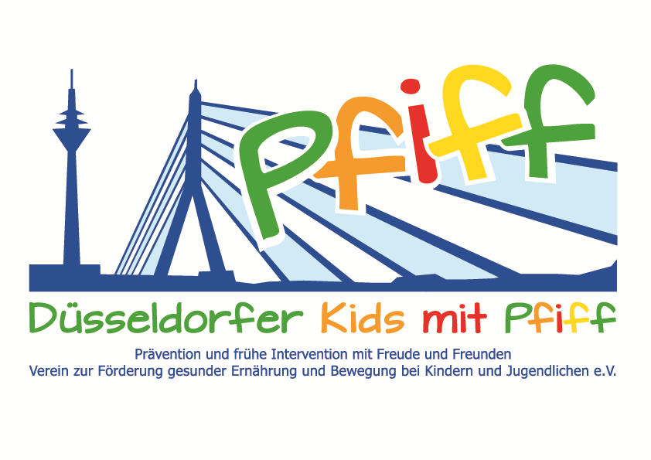
Düsseldorf, June 11, 2018

Press Release

Fortuna Düsseldorf Supports Fight Against Diabetes

Fortuna Düsseldorf invites the primary school children participating in the SMS Initiative to the Young Talent Center at Flinger Broich.
(Düsseldorf, June 11, 2018) For the young Fortuna fans there is another reason to be happy besides the promotion to the first Bundesliga this summer. Düsseldorf's most successful football club offered the primary school pupils of the initiative "SMS. Be smart. Join in. Be fit" a football training session at Flinger Broich. Under the guidance of experienced coaches of the Fortuna youth teams, the participating pupils of the GGS Am Köhnen and the St. Michael School had the opportunity to sniff the air of professional football and emulate its idols. After joint warm-up and stretching exercises, the program included technical and goal-shooting training. Finally, the primary school children played against each other in small teams. Fortuna attaches particular importance to fair play and the respectful treatment of each other.
”In youth training, we want to offer children the opportunity to play football with heart, passion, emotions and enthusiasm. Our youth players should experience a sense of togetherness, mutual acceptance and tolerance in our club. In addition, the players learn how important a balanced diet is in order to optimally access their athletic and mental performance. That's how we want to prepare them for future tasks on the football field and beyond, " said Christian Lasch, Educational Coordinator of the Young Talent Center at Fortuna Düsseldorf, emphasizing the importance of team sports and a healthy lifestyle. "For the children, the training at Flinger Broich is really a special highlight for which they can hardly wait. It is very nice to experience with how much joy and enthusiasm the students participate in the training, " said SMS project leader Professor Karsten Müssig.
Bildunterschrift: Children of the St. Michael School during a football training session at Fortuna Düsseldorf (Source: Düsseldorf Kids with Pfiff/SMS).

The initiative led by Professor Müssig, “SMS. Be smart. Join in. Be fit." in Düsseldorf primary schools seeks to counteract overweight and other lifestyle-related diseases in childhood and adolescence. The SMS initiative is sponsored by the association Düsseldorfer Kids mit PFIFF and is scientifically supported by the German Diabetes Center (DDZ). The participating children complete the “aid” nutrition pilot license program in cooperation with the Health Education Center for Dietary Assistants of the Kaiserswerther Diakonie and take part in the exercise program for primary schools “Fitness for Kids” developed by sports scientist Professor Kerstin Ketelhut. In addition, the pupils are taught how to deal with stress in the sensory classroom of the Präha Weber School in a motor skills training course. They are also taught relaxation exercises in cooperation with the initiative “Physical Activity during School Recess” of the Dietrich Grönemeyer Foundation and the Deichmann company .The two health insurance companies IKK classic and KKH, the organization diabetesDE - German Diabetes Aid, the Sports Department of Düsseldorf and other renowned partners and prominent people support the project and provide the participating school children with additional attractive venues for learning outside of school. The patron of the initiative is Thomas Geisel, mayor of the state capital Düsseldorf.
In 2015 the SMS initiative was awarded the supporter logo of IN FORM – Germany’s initiative for a healthy diet and more exercise, and in 2016 was awarded the GUT DRAUF label of the German Center for Health Education (BZgA).
.

For more information on the initiative, see: www.sms-mach-mit.de

