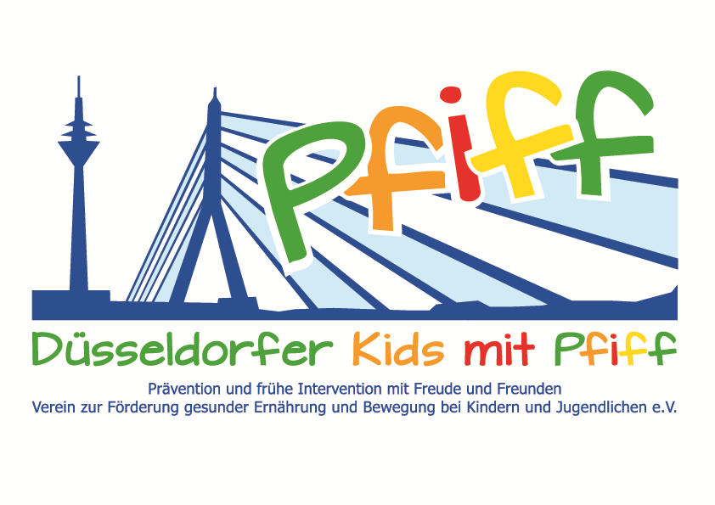
Düsseldorf, June 20, 2018

Press Release

Discovering the Diversity of Herbs Using All the Senses
The primary school children participating in the SMS initiative visit the Central School Garden of the City of Düsseldorf.

(Düsseldorf, June 12, 2018) Throughout the year, supermarkets and discounters offer a wide variety of fruits, vegetables and herbs. Nevertheless, people are increasingly choosing processed food products and are preparing their meals from scratch less and less often. However, this is a basic requirement for a healthy diet. Herbs in particular refine the taste and flavor of every dish. In the next few weeks, in Düsseldorf‘s Central School Garden, the pupils participating in the SMS initiative "SMS. Be smart. Join in. Be fit." will learn about the great variety of garden herbs, the origin of the plants, and which herbs can be grown on the window sill at home.

To explain the project to you, we cordially invite you to join us
on Thursday, June 14, 2018, from 11:00 a.m. – 12:30 p.m. when the Mosaikschule is a guest.
Venue: Central School Garden, Räuscherweg 40, 40221 Düsseldorf
Your contact persons:
• Prof. Dr. Karsten Müssig, Head of the initiative "SMS. Be smart. Join in. Be fit." • Frau Ponz-Lövenich, Mosaikschule
• Sascha Grünewald, Organizer of the Central School Garden
• Burkhard Hintzsche, City Director of the State Capital of Düsseldorf
• Martina Hankammer, Provincial Cultural and Social Foundation

During a guided tour through the herb garden with Sascha Grünewald, organizer of the central school garden, the children will learn exciting stories about the individual herbs and their different uses under the motto "Witches’ Kitchen 1-2-3". In order to discover the variety of herbs with all the senses, the primary school pupils will then prepare a herbal snack which they will eat together at the end of the visit.
"Many children today no longer know what the different vegetables and herbs look like, what they are called or where they come from. With our Central School Garden, we want to introduce primary school pupils to the diversity and origin of plant foods and arouse their interest in nature and natural foods," said Sascha Grünewald, explaining his commitment to the Central School Garden. "The SMS initiative aims to raise children's awareness of a balanced diet and regular exercise. By focusing intensively on natural foods, we want to increase acceptance and appreciation of our crops and show them how delicious healthy food is and how much fun cooking together can be," added project leader Professor Karsten Müssig.
The initiative led by Professor Müssig, “SMS. Be smart. Join in. Be fit." in Düsseldorf primary schools seeks to counteract overweight and other lifestyle-related diseases in childhood and adolescence. The SMS initiative is sponsored by the association Düsseldorfer Kids mit PFIFF and is scientifically supported by the German Diabetes Center (DDZ). However, such a project cannot be implemented without financial support. "That is why we are delighted with this year's support from the Provincial Cultural and Social Foundation, which contributed 3,000 euros," said Professor Müssig. Martina Hankammer, spokeswoman of the foundation added: "Today's children will shape the society of the future, in which nutrition and exercise will play a major role. An introduction to the topic cannot start early enough. We are therefore pleased to support this project of the association, which we consider to be so important."
City director Burkhard Hintzsche is also enthusiastic about the project: "The earlier the awareness of nature and a healthy lifestyle is shaped, the better. People’s eating habits are learned in childhood and later largely retained. The active participation in the preparation of the dishes not only strengthens the identification of the children but also ensures the equally important fun factor. "

The initiative led by Professor Müssig, “SMS. Be smart. Join in. Be fit." in Düsseldorf primary schools seeks to counteract overweight and other lifestyle-related diseases in childhood and adolescence. The SMS initiative is sponsored by the association Düsseldorfer Kids mit PFIFF and is scientifically supported by the German Diabetes Center (DDZ). The participating children complete the “aid” nutrition pilot license program in cooperation with the Health Education Center for Dietary Assistants of the Kaiserswerther Diakonie and take part in the exercise program for primary schools “Fitness for Kids” developed by sports scientist Professor Kerstin Ketelhut. In addition, the pupils are taught how to deal with stress in the sensory classroom of the Präha Weber School in a motor skills training course. They are also taught relaxation exercises in cooperation with the initiative “Physical Activity during School Recess” of the Dietrich Grönemeyer Foundation and the Deichmann company .The two health insurance companies IKK classic and KKH, the organization diabetesDE - German Diabetes Aid, the Sports Department of Düsseldorf and other renowned partners and prominent people support the project and provide the participating school children with additional attractive venues for learning outside of school. The patron of the initiative is Thomas Geisel, mayor of the state capital Düsseldorf.
In 2015 the SMS initiative was awarded the supporter logo of IN FORM – Germany’s initiative for a healthy diet and more exercise, and in 2016 was awarded the GUT DRAUF label of the German Center for Health Education (BZgA).
.

For more information on the initiative, see: www.sms-mach-mit.de

