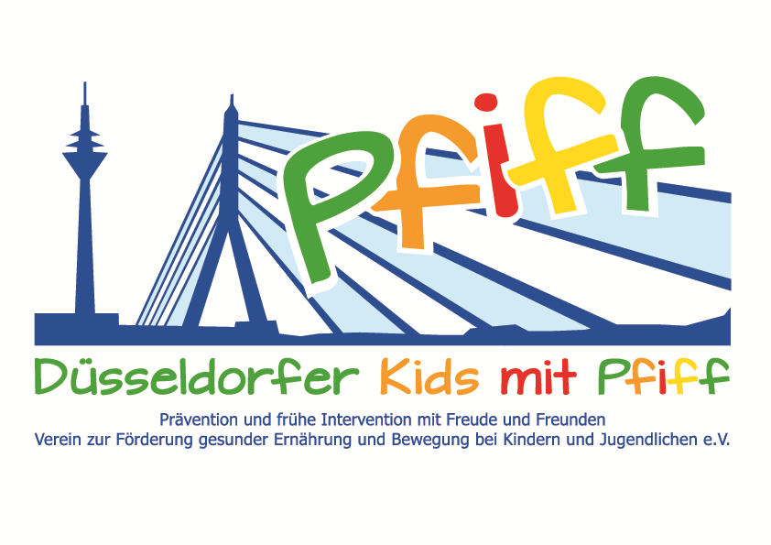
Düsseldorf, June 13, 2018

Press Release

Exercise and Fun in the Water
With the Aqua Trampoline, the Düsseldorf municipal swimming pool company offers the children participating in the SMS initiative a fun exercise session in the water.

(Düsseldorf, June 13, 2018) A healthy lifestyle helps to avoid obesity and other lifestyle-related diseases such as diabetes. To integrate this into everyday life over the long term, the fun factor of a balanced diet and regular exercise plays a decisive role. Having fun doing exercise is also the top priority for the Aqua Trampoline: Who doesn't associate trampoline jumping with happy and laughing children? Now, the primary school pupils of the KGS Höhenstraße can find out that trampoline jumping is not only possible on land, but also under water. On Thursday, June 14, 2018 the Düsseldorf municipal swimming pool company is offering the children participating in the initiative "SMS. Be smart. Join in. Be fit"“ an aqua trampoline session in the indoor swimming pool in Bilk. The innovative exercise program "AquaTrampoline für Kids" was developed in 2013 by the Düsseldorf municipal swimming pool company and sports scientist Romina Walterowicz. The aim of the program is to teach children the fun of moving in the water in a completely new way. During the course, the students move on an underwater trampoline and practice a choreography to the accompanying music. Almost all muscle groups are used. In addition, the exercise program in the water is easy on the joints and trains balance as well as the children’s coordination and motor skills. The aqua trampoline course is led by the trained physiotherapist and course instructor Lena Eich.

"With the Aqua Trampoline, we want to combine the fun of exercise with the positive effects of water on the body. The children shall learn that water as space for exercise is not only a venue for classical swimming lessons but also offers many exercise possibilities,“ said Lena Eich explaining the commitment of the Düsseldorf municipal swimming pool company. “The SMS initiative aims to convey to the primary school children how much fun a balanced diet and regular exercise can be. The aqua trampoline course is an excellent way of showing children how many different exercise options there are and how much fun it is to exercise," said SMS project leader Professor Karsten Müssig.

Date and Venue:
Thursday, June 14, 2018, 10:15 – 11:00 a.m.
Schwimm` in Bilk, Bachstraße 145, 40217 Düsseldorf

The initiative led by Professor Müssig, “SMS. Be smart. Join in. Be fit." in Düsseldorf primary schools seeks to counteract overweight and other lifestyle-related diseases in childhood and adolescence. The SMS initiative is sponsored by the association Düsseldorfer Kids mit PFIFF and is scientifically supported by the German Diabetes Center (DDZ). The participating children complete the “aid” nutrition pilot license program in cooperation with the Health Education Center for Dietary Assistants of the Kaiserswerther Diakonie and take part in the exercise program for primary schools “Fitness for Kids” developed by sports scientist Professor Kerstin Ketelhut. In addition, the pupils are taught how to deal with stress in the sensory classroom of the Präha Weber School in a motor skills training course. They are also taught relaxation exercises in cooperation with the initiative “Physical Activity during School Recess” of the Dietrich Grönemeyer Foundation and the Deichmann company .The two health insurance companies IKK classic and KKH, the organization diabetesDE - German Diabetes Aid, the Sports Department of Düsseldorf and other renowned partners and prominent people support the project and provide the participating school children with additional attractive venues for learning outside of school. The patron of the initiative is Thomas Geisel, mayor of the state capital Düsseldorf.
In 2015 the SMS initiative was awarded the supporter logo of IN FORM – Germany’s initiative for a healthy diet and more exercise, and in 2016 was awarded the GUT DRAUF label of the German Center for Health Education (BZgA).

For more information on the initiative, see:: www.sms-mach-mit.de

