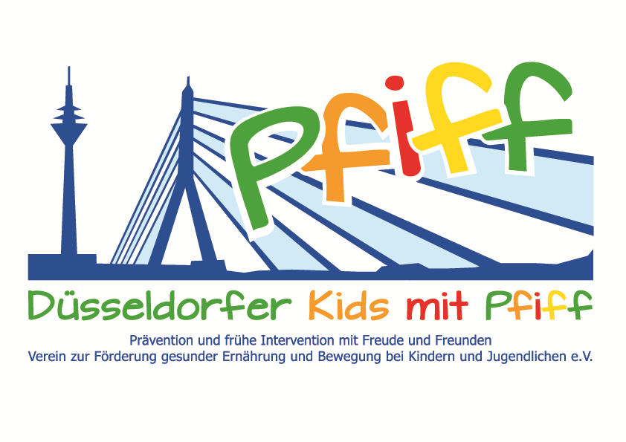
Düsseldorf, June 25, 2018

PRESS RELEASE

Sensory Training to Support Healthy Development
The advanced training course in motor skills training of the Präha Weber School conducts a sensory classroom with the primary school children participating in the SMS initiative.

(Düsseldorf, June 22, 2018) More and more children today are not physically active enough and have motor deficits already at an early age. Simple exercises like running backwards, hopping on one foot or balancing are difficult for many children. In addition, many pupils find everyday school life stressful and are under pressure to meet high expectations. According to the World Health Organization (WHO), schools in particular should provide a healthy environment for children to counteract the risk of lifestyle-related diseases such as obesity and diabetes. In view of this, the initiative "SMS. Be smart. Join in. Be fit" aims to develop the participating pupils’ awareness of a balanced diet and the need for regular exercise. On Monday, June 25, 2018, a sensory classroom will be held in elementary schools in cooperation with the advanced training course in motor skills training conducted by the Präha Weber School. The goal of the sensory classroom is to provide children with a basis for their behavior, feelings and learning by promoting exercise, motor skills and body perception This year, the pupils of the Catholic Elementary School Mettmanner Straße and the municipal elementary school Flurstraße have the opportunity to take part in a sensory parcours and play games to practice gross and fine motor skills in the various sensory areas, to discover new forms of exercise and to thereby train the senses.

“Our training session aims to show children how easy it is to integrate exercise into one‘s daily routine and how much fun an active lifestyle can be. Especially considering the children’s long school days and many after-school activities, it is important that they develop a feeling for their own body early on and find ways of dealing with stress,“ said Susanne Schwalbe, director of the Weber School, emphasizing the need to raise children’s awareness of a healthy lifestyle early on. The sensory classroom highlights the fact that children can have fun exercising even in the smallest of spaces. Many exercises can also be carried out at home without much effort and have an additional positive effect on the children’s body perception,“ said SMS project leader Professor Karsten Muessig, MD.

Date:
Monday, June 25, 2018, 12:00 noon – 1:30 p.m.
GGS Flurstraße, Flurstraße 59, 40235 Düsseldorf

Bildunterschrift: Pupils of the GGS Flurstraße guided by motor skills therapists of the Präha Weber School Düsseldorf (Photo: Düsseldorfer Kids mit PFIFF e.V.).

The initiative led by Professor Müssig, “SMS. Be smart. Join in. Be fit." in Düsseldorf primary schools seeks to counteract overweight and other lifestyle-related diseases in childhood and adolescence. The SMS initiative is sponsored by the association Düsseldorfer Kids mit PFIFF and is scientifically supported by the German Diabetes Center (DDZ). The participating children complete the “aid” nutrition pilot license program in cooperation with the Health Education Center for Dietary Assistants of the Kaiserswerther Diakonie and take part in the exercise program for primary schools “Fitness for Kids” developed by sports scientist Professor Kerstin Ketelhut. In addition, the pupils are taught how to deal with stress in the sensory classroom of the Präha Weber School in a motor skills training course. They are also taught relaxation exercises in cooperation with the initiative “Physical Activity during School Recess” of the Dietrich Grönemeyer Foundation and the Deichmann company .The two health insurance companies IKK classic and KKH, the organization diabetesDE - German Diabetes Aid, the Sports Department of Düsseldorf and other renowned partners and prominent people support the project and provide the participating school children with additional attractive venues for learning outside of school. The patron of the initiative is Thomas Geisel, mayor of the state capital Düsseldorf.
In 2015 the SMS initiative was awarded the supporter logo of IN FORM – Germany’s initiative for a healthy diet and more exercise, and in 2016 was awarded the GUT DRAUF label of the German Center for Health Education (BZgA).
.

For more information on the initiative, see: www.sms-mach-mit.de

