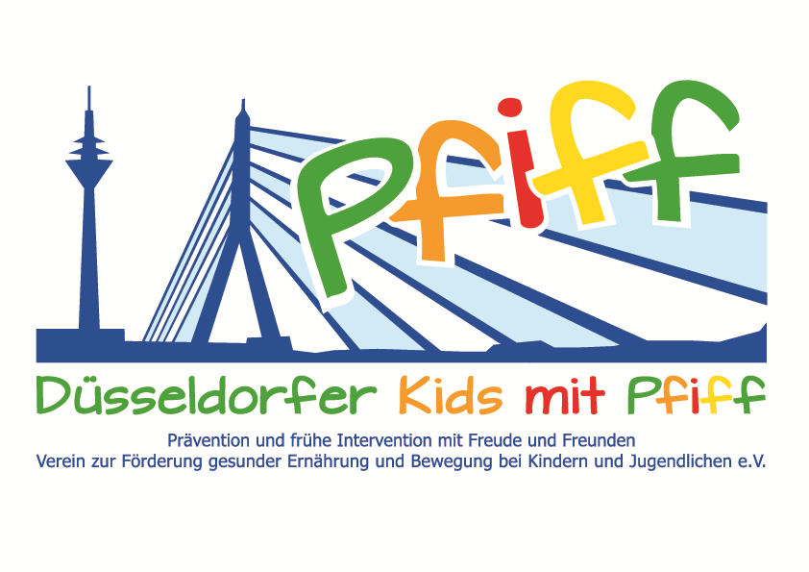
Düsseldorf, June 28, 2018

Press Release

Inspiring Children to Exercise
High Jump Champion Hendrik Beyer visited the Mosaikschule and conducted a sports session with children participating in the SMS initiative.

(Düsseldorf, 25.06.2018) The pupils participating in the initiative “SMS. Be smart. Join in. Be fit.” will certainly remember this sports session for a long time to come. On Tuesday, June 26, 2018, Hendrik Beyer, multiple German champion and Olympic participant in the high jump, conducted a sports session at the Mosaikschule. To start with, the pupils had the opportunity to get to know the likeable athlete and ask him questions about his sport, competitions and training as well as his life as a competitive athlete. As illustration and to facilitate better understanding of the sport, he showed the two school classes a medal and special sports shoes with spikes from his active time as a high jumper. Subsequently, a joint exercise session took place in which the main focus was on the fun and enjoyment of exercise.
"In our latitudes, we have the special good fortune of always having a huge supply of food and beverages and being able to consume them according to our desires and tastes. Therefore, it is even more important for children to learn early on which foods make up a balanced diet and how important a healthy lifestyle is for their development. I am very happy to support the SMS initiative in inspiring the participating school children to exercise regularly," said Hendrik Beyer, German champion in high jump and SMS sponsor, explaining his commitment. "Who could convey the importance of regular exercise and a balanced diet more credibly than successful athletes? We are very happy about the support of the SMS sponsors. For the participating school classes it is always something very special when a prominent athlete comes to their school,” added SMS project leader Professor Karsten Müssig, MD.
The initiative led by Professor Müssig, “SMS. Be smart. Join in. Be fit." in Düsseldorf primary schools seeks to counteract overweight and other lifestyle-related diseases in childhood and adolescence. The SMS initiative is sponsored by the association Düsseldorfer Kids mit PFIFF and is scientifically supported by the German Diabetes Center (DDZ). The participating children complete the “aid” nutrition pilot license program in cooperation with the Health Education Center for Dietary Assistants of the Kaiserswerther Diakonie and take part in the exercise program for primary schools “Fitness for Kids” developed by sports scientist Professor Kerstin Ketelhut. In addition, the pupils are taught how to deal with stress in the sensory classroom of the Präha Weber School in a motor skills training course. They are also taught relaxation exercises in cooperation with the initiative “Physical Activity during School Recess” of the Dietrich Grönemeyer Foundation and the Deichmann company. The two health insurance companies IKK classic and KKH, the organization diabetesDE - German Diabetes Aid, the Sports Department of Düsseldorf and other renowned partners and prominent people support the project and provide the participating school children with additional attractive venues for learning outside of school. The patron of the initiative is Thomas Geisel, mayor of the state capital Düsseldorf.
In 2015 the SMS initiative was awarded the supporter logo of IN FORM – Germany’s initiative for a healthy diet and more exercise, and in 2016 was awarded the GUT DRAUF label of the German Center for Health Education (BZgA).

For more information on the initiative, see: www.sms-mach-mit.de

