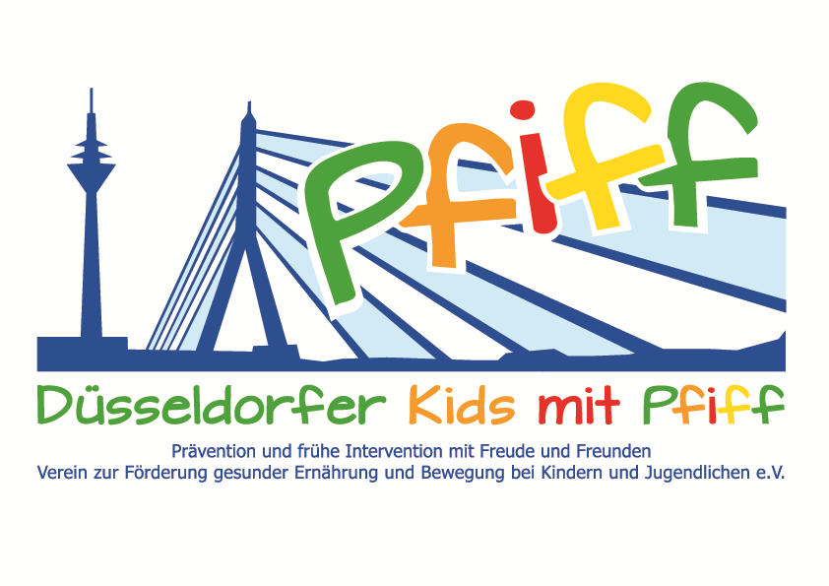
Düsseldorf, July 12, 2018

Press Release

Fascination Judo: Promotion of a Healthy Lifestyle and Transmission of Values
The Judo Club 71 offers the elementary school students of the SMS initiative a judo trial training.

(Düsseldorf, July 9, 2018) Once we start school, we spend most of the day sitting down doing sedentary activities. At the same time, we have an almost unlimited supply of food available everywhere. These factors often lead to an imbalance between energy intake and energy consumption due to a lack of physical activity, thus promoting the development of overweight. This is the reason why the initiative “SMS. Be smart. Join in. Be fit." is committed to creating favorable conditions for children to grow up healthy and to enabling the long-term prevention of overweight and lifestyle-related diseases. The aim of the SMS initiative is to raise children‘s awareness of the fun and importance of a balanced diet and regular exercise. The initiative is supported by the Düsseldorf Judo Club 71. Judo combines the components of motor skills, fitness, speed and strength and thus offers an excellent opportunity to strengthen and increase the mobility and motor skills of children, but also of young people and adults. In addition, this traditional martial art teaches values such as mutual respect, thus helping children learn to resolve conflicts nonviolently. As part of the SMS initiative, the participating students of KGS Höhenstraße and GGS Am Köhnen now have the opportunity to gain an insight into the diversity of judo. In addition to learning the history and the basic rules as well as the judo bowing rituals, the elementary school children under the direction of Thomas Jansen, judo coach of the Düsseldorf Judo Club 71 learn different throwing and holding techniques and can then apply what they have learned in a training match.

“Judo training promotes flexibility and motor skills and supports the natural drive of children to test each other in a cultivated way. At the same time, the children learn to treat each other respectfully, shy children develop a healthy self-confidence, and aggressive children learn to be considerate. These are valuable skills that also help the children in daily life and at school," said judo coach Thomas Jansen. "With the SMS initiative we want to show the children the variety of sports activities and raise their awareness of the importance of regular exercise and respectful cooperation. Judo is ideal for that,” said Professor Karsten Müssig, project leader of the SMS initiative.

Date and Time:
Wednesday, July 11, 2018, 10:00 am – 11:30 am

Venue:
Lessing-Gymnasium, Ellerstraße 84, 40227 Düsseldorf

The initiative “SMS. Be smart. Join in. Be fit." led by Professor Karsten Müssig at Düsseldorf primary schools seeks to counteract overweight/obesity and other lifestyle-related diseases in childhood and adolescence. The children earn their “aid” nutrition pilot license in cooperation with the Educational Center for Dietary Assistants of the Kaiserswerther Diakonie and take part in the exercise program for primary schools “Fitness for Kids” developed by sports scientist Professor Kerstin Ketelhut.
In addition, the pupils experience the perception of their own body in the sensory classroom of the Präha Weber School in a motor skills training course. They are also taught relaxation exercises in cooperation with the initiative “Physical Activity during School Recess” of the Dietrich Grönemeyer Foundation and the Deichmann company. The two health insurance companies IKK classic and KKH, the organization diabetesDE - German Diabetes Aid, the Sports Department of Düsseldorf and other renowned partners and prominent people support the project and provide the participating school children with additional attractive venues for learning outside of school. The patron of the initiative is Thomas Geisel, mayor of the state capital Düsseldorf. In 2015 the SMS initiative was awarded the support logo of IN FORM – Germany’s initiative for a healthy diet and more exercise, and in 2016 was awarded the GUT DRAUF label of the German Center for Health Education (BZgA).

.

For more information on the initiative, see: www.sms-mach-mit.de

