PRESS RELEASE

New Competence Center for Innovative Diabetes Therapy (KomIT) Funded by NRW and EU

Over the next three years, a new competence center will be established at the German Diabetes Center (DDZ) with funds from the state of North Rhine-Westphalia and the EU amounting to around 3.5 million euros. The new competence center is to be set up in cooperation with a consortium of eight partners from industry and university research to promote the targeted development of new therapies for diabetes. The aim of the center coordinated by the DDZ is the efficient translation of innovative research results into clinical applications to improve patients’ diabetes management.

Düsseldorf (DDZ) – The steadily rising number of diabetes patients in Germany and the associated socio-economic burden on the health system urgently require the development of new approaches to causal therapies.
"Together with our partners, we want to build up a sustainable infrastructure to bring innovative approaches to diabetes treatment quickly and directly to patients," said Professor Michael Roden, director of the German Diabetes Center and coordinator of the new Competence Center for Innovative Diabetes Therapy (KomIT). "Our joint activities should bundle competencies and lead to scientific and technological breakthroughs in diabetes research." In addition to the German Diabetes Center (DDZ), Algiax Pharmaceuticals GmbH, Taros Chemicals GmbH & Co. KG, Lead Discovery Center GmbH (LDC), vivo Science GmbH, A & M Labor für Analytik und Metabolismusforschung GmbH, PROFIL Institut für Stoffwechselforschung GmbH and TU Dortmund University with the Drug Discovery Hub Dortmund (DDHD).

In North Rhine-Westphalia, excellent basic research has already been carried out in clinical-experimental diabetes studies for a long time. However, the current translation of these results into clinical application is not yet sufficient to generate sustained economic growth. Start-ups and small companies with high innovation potential are often unable to carry out extensive experimental and clinical research with sufficient critical mass and within the required time frame. This is where the new interdisciplinary Competence Center for Innovative Diabetes Therapy (KomIT) comes in. The central idea is the establishment of a sustainable infrastructure that bundles expertise from management, development and medical chemistry, preclinical and analytical research, toxicology and physiology up to and including clinical trials and that provides an open platform for NRW, Germany and Europe.

This innovative research infrastructure will provide important impulses for the pharmaceutical and biotech sector in NRW and, in addition, sustainably strengthen the innovative strength and competitiveness of NRW. The project is being funded under the EFRE.NRW program – Investments in Growth and Employment of the State of North Rhine-Westphalia and the European Union.

Photo (from right): Prof. Dr. Michael Roden, coordinator of the Competence Center for Innovative Diabetes Therapy (KomIT), with Prof. Dr. Jürgen Eckel, managing director of KomIT and Prof. Dr. Eckhard Lammert, director of the Institute for Vascular and Islet Cell Biology, are the contact persons at the German Diabetes Center and are looking forward to working with the partners.

More information: https://www.efre.nrw.de

(February 19, 2019)

The German Diabetes Center (DDZ) serves as the German reference center for diabetes. Its objective is to contribute to the improvement of prevention, early detection, diagnosis and treatment of diabetes mellitus. At the same time, the research center aims at improving the epidemiological data situation in Germany. The DDZ coordinates the multicenter German Diabetes Study and is a point of contact for all players in the health sector. In addition, it prepares scientific information on diabetes mellitus and makes it available to the public. The DDZ is part of the Leibniz Association (Wissenschaftsgemeinschaft Gottfried Wilhelm Leibniz, WGL) and is a partner of the German Center for Diabetes Research (DZD e.V.).

Recent press releases of the DDZ are available at www.ddz.uni-duesseldorf.de

The press photos of the DDZ may be used for editorial purposes only and should be attributed under “Photo Credits” as: "Source: DDZ e.V." There is no charge for the use of photos, but please send us a copy or a reference to the respective publication.

For more information, please contact:
Christina A. Becker  Head, Press and Public Relations  German Diabetes Center(DDZ)  Leibniz Center for Diabetes Research  at the Heinrich Heine University of Düsseldorf  Phone: 0211-3382-450  email: Christina.Becker@ddz.de | Prof. Dr. Jürgen Eckel  Managing Director KomIT  German Diabetes Center(DDZ)  Leibniz Center for Diabetes Research  at the Heinrich Heine University of Düsseldorf  Phone: 0211-3382-561  email: Juergen.Eckel@ddz.de
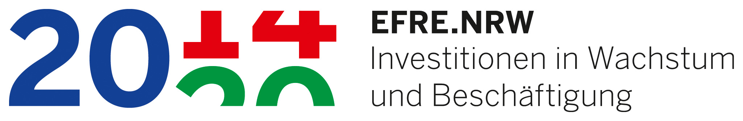 | 